Module Three Home Page:

<http://krausladenshome.centralus.cloudapp.azure.com/module3/salesapp/apphome.html>

Module Three PHP Execution Page:

<http://krausladenshome.centralus.cloudapp.azure.com/module3/salesapp/viewdataphp.html>

Module Three Gitup upload

<https://github.com/Krausladen/MWAD_ClassFolder>

PHP Execution Page:

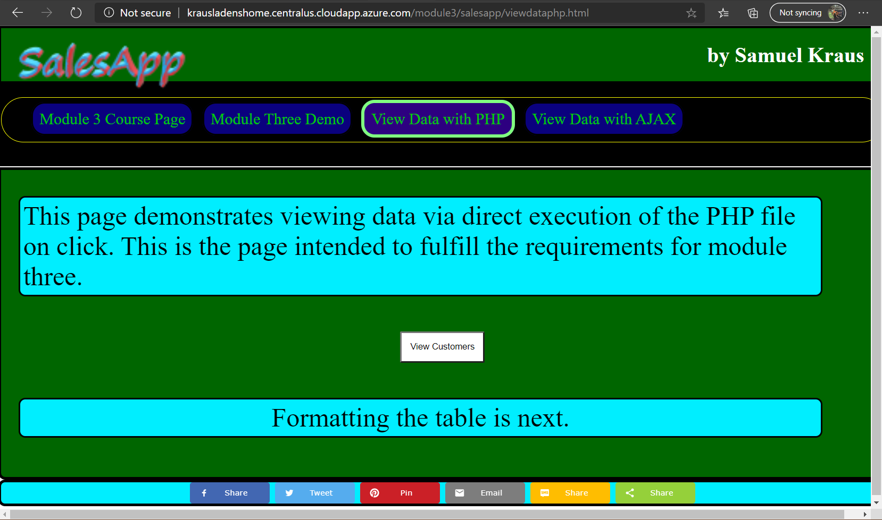

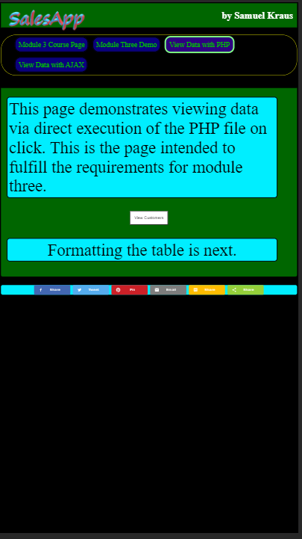

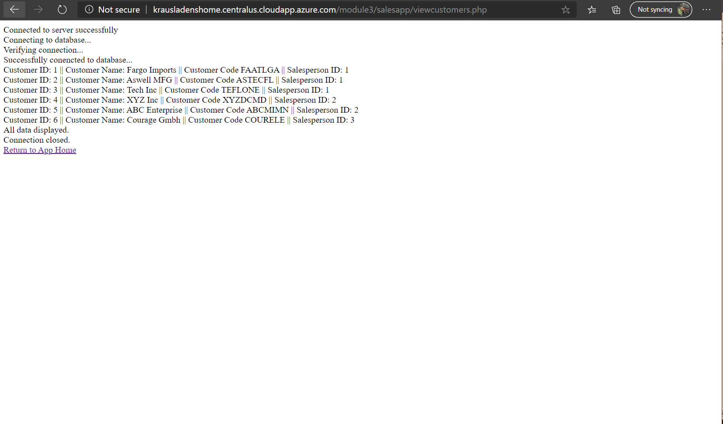

I started off trying to build an insert form, struggled with that for a day or two before turning to the actual homework assignment. Once I got the PHP syntax figured out I worked on the CSS file to make the page unique.  
I was also able to figure out how to implement a share bar into the footer of the page.   
  
The AJAX page isn’t finished yet, that page will be the final version of the module three assignment, populating PHP data that is formatted while allowing a user to insert data into the various tables.